**The Plastics**

**What is our Vessel Name?**

1. Autonomous Sea Waste Transport System (ASWT System)?
2. Autonomous Sea Waste Collection Transport Vessel (ASWC Transport Vessel)?
3. Sea Garbage Vessel (SGV)

**User Story:**

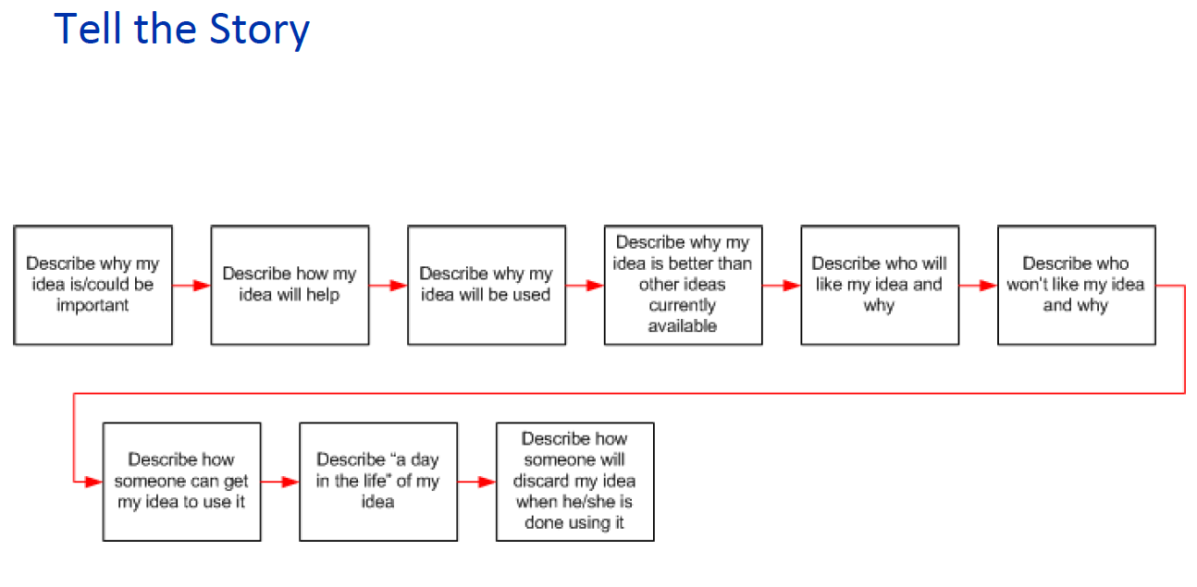

Transport System will use sustainable materials and design processes with minimal environmental impact which will reduce ocean pollution and increase recycling processing of the ocean’s waste. Transport system will be operated mostly autonomously with minimal logistics and maintenance needs which will reduce the overall life cycle cost. Our transport System will use 100% renewable energy source for operation to fulfill stakeholders such as environmentalists, coastal communities, and the project sponsor. Transport system will also be required to address concerns from the marine life organizations and community members against this initiatives. Once Transport System design is verified and validated, the transport system will be ready for operational use. Transport system will be autonomously operated and will be operational 365 days per year with service interruptions only for prescribed maintenance or as-needed repair. The system will shipped off a docking station autonomously navigated to the collection center to collect waste and transported back to the recycling center. The transport system will be decommissioned through use of either recycle materials or reuse of specific subsystems through a modular architecture.

**Stakeholder Analysis:**

**Organizations:**

1. Customer (Project Sponsor)
   1. Non-Profit Environmental Organizations
   2. Coastal community investors
2. Government Entities (Laws and Regulatory)
3. Coastal Community (Environmentalists)
4. Coastal Community (Non-environmentalists)
5. Marine Life Organizations

**Operation:**

1. Scientist/ Researchers
2. Pirates
3. Satellite Operators/Designer
4. Hackers
5. Shipping Lane Users
6. Recycling Staff
7. Operator at Collection Site? (assume unmanned)
8. Vehicle Operator (Ground station)
9. Other Transport Vehicles (Commercial, Military)

**Pilot:**

1. Boat Pilot
2. Helicopter Pilot
3. Rescue Boat Pilot / Emergency Pilots
4. Harbor/Port Pilot

**Maintenance:**

1. Maintenance Personnel

**Safety:**

1. Safety Personnel

**Bunkering:**

1. Bunker Operator

**Use Case Analysis (Covered in FFBD as well)**

* **Main Functions/Use Cases:**
  + Navigate out of Port
  + Offload Pilot
  + Navigate to Collection system(s)
  + Broadcast GPS Coordinates
  + Dock at Collection site
    - Plug in Power to Collection Facility Conveyor System
  + Receive waste
    - Unplug Power from Collection Facility Conveyor System
  + Undock from Collection Facility
  + Navigate into Port
  + Onboard Pilot
  + Dock at Recycling Center (Post-Deployment)
  + Transfer waste to Recycling Center
  + Navigate to Bunkering location
  + Perform Maintenance Operations at Bunkering Location

**Stakeholder Needs (See Cameo Use Case Diagram)**

**Mission Statement:**

The Plastics Sea Waste Transport System will implement a sustainable, modular architecture that will enable an incremental technology advancement and global expansion capability to foster the reduction of ocean’s pollution.

The Autonomous Sea Waste Transport System loads sea waste collected from the “Great Pacific Garbage Patch” and transports it to a land-based recycling and processing center on the coast without human intervention to improve the local environment of coastal communities and reduce human impact to marine ecosystems.

The sea waste transport system is intended to load sea waste collected from the “Great Pacific Garbage Patch” and transport it to a land-based recycling and processing center on the coast of either California or Hawaii.

The Autonomous Sea Waste Collection System (ASWCS) transports a minimum of 6,460 cubic feet of plastic waste from sea-based collection systems to a land-based recycling facility with human interaction only in shipping lanes and in port. The ASWCS operates continuously, with a maximum downtime of seven days within any four month period.

**Context Diagrams (See Excel)**

**FFBD (See Visio)**

**Requirements:**

**Functional Requirements:**

1. The Sea Garbage Vessel (SGV) shall load sea waste collected from the “Great Pacific Garbage Patch”
2. The SGV shall transport the waste to a land-based recycling and processing center on the coast of either California or Hawaii.

**Interface Requirements:**

1. The ASWCS shall interface with the collection system via four hooks.
2. The ASWCS shall receive an optical signal from the collection system.
3. The ASWCS transport vessel shall supply 50 A of 220 VAC power to the sea-based collection system conveyor belt.
4. The ASWCS transport vessel shall autonomously plug in the connector required to supply 220 VAC power to the sea-based collection system conveyor belt.

**Performance Requirements:**

1. The ASWCS transport vessel shall have a minimum range of 3500 nautical miles.
2. The ASWCS transport vessel shall be piloted while in port, as well as between the harbor and any shipping lane.
3. The ASWCS transport vessel shall maintain a minimum distance of 0.25 nautical miles from all other vessels while operating in autonomous mode.
4. Control and communication channels to and from the ASWCS transport vessel shall be encrypted.
5. The ASWCS transport vessel shall broadcast its position to a ground station at intervals not to exceed (TBR).
6. The ASWCS transport vessel shall broadcast changes in status to a ground station, such as underway to docking, docking to docked, transferring waste, etc.
7. The ASWCS transport vessel shall broadcast changes in cargo weight and volume.
8. The ASWCS transport vessel shall autonomously dock with sea-based waste collection systems using a documented hardware interface.
9. The ASWCS transport vessel shall autonomously on-load plastic waste from a conveyor belt located at a height of 20 feet above the waterline.
10. The ASWCS transport vessel shall receive plastic waste from the sea-based collection system conveyor belt at a maximum rate of 20 cubic feet per minute.
11. The ASWCS transport vessel shall have a minimum waste cargo capacity of 6460 cubic feet.
12. The ASWCS transport vessel shall be capable of traveling a maximum distance of 2400 nautical miles in 10 days (TBR map distance vs "sea route" distance).
13. The ASWCS transport vessel shall be capable of offloading the waste cargo to a height of 30 feet above waterline.
14. The ASWCS shall have living quarters and associated amenities (lavatory, kitchen, etc) for up to five research personnel.

**Environments:**

1. The ASWCS transport vessel shall be capable of docking with the sea-based collection system with ocean swells up to a maximum of six feet.

**Design and Construction:**

**Maintainability:**

1. The SGV shall not exceed a maximum duration of allowable down time of 7 days every 4 months.
2. The SGV service interruptions shall only be for prescribed maintenance or as-needed repair.

**Safety:**

1. The SGV for any anomalous situations that require human intervention shall be communicated to the ground station (via ?).
2. Any personnel that will be required to respond to anomalous situations on the SGV shall be transported to the vessel by helicopter, if in range. If out of range, they will travel by surface vessel.
3. The ASWCS shall have all necessary safety systems (running lights, audio indicators, radar, etc.) as required to communicate with other vessels while under way.

**Design to Cost:**

1. The budget for production, maintenance, and operation of at least one ASWCS transport vessel for a period of three years shall not exceed 56 million dollars.
2. All elements of the ASWCS shall be in service prior to August 1, 2021. (Yeah, that's gonna happen.)

**Goal Requirements:**

1. The ASWCS shall have living quarters and associated amenities (lavatory, kitchen, etc) for up to five research personnel.
2. The ASWCS shall use 100% renewable energy source.